**DNS Enumeration**

DNS (Domain Name System) is one of the most important parts of the internet infrastructure that converts domain names into IP addresses and vice-versa, which is used by computers to identify each other on the internet and local networks.

Let’s understand how DNS works:

* When you enter a domain name (for example, [www.google.com](http://www.example.com/)) in your browser, your computer must find the corresponding IP address.
* Firstly, your computer looks in its own local DNS cache to see if it already knows what the IP address should be.
* If it does not find it locally, an inquiry will be sent to a DNS resolver, usually one offered by your Internet Service Provider (ISP).
* The resolver checks its cache and if it’s not there, it starts a recursive search:-
  + Starting with root nameservers asking for information about top-level domain (.com in this case)
  + Then .com nameservers are asked about example.com
  + Lastly example.com nameservers are asked about [www.google.com](http://www.example.com/)
* After finding the IP address, it is sent back to your computer.
* Your machine caches this information locally for future use and connects to the website via this IP.

This typically happens very quickly within milliseconds. The DNS uses numerous servers distributed across the globe in a hierarchical manner to effectively handle such a tremendous number of requests.

DNS enumeration systematically queries and gathers information about a domain's DNS records and structure. This includes identifying IP addresses, subdomains, mail servers, name servers, and other DNS records.

Here’s a step-by-step guide to performing DNS enumeration using various tools and techniques.

### **Tools and Techniques for DNS Enumeration**

#### **1. Basic DNS Queries**

**nslookup and dig:** These built-in command-line tools are essential for querying DNS records.

* **nslookup (Name Server Lookup)**: nslookup is a basic and common tool that helps users query DNS servers and get information about domain names or IP addresses.

**Key Features:**

* **Basic Queries:** Finds A record (IP address) or other DNS records such as MX, NS, etc.
* **Interactive Mode:** It lets you make ongoing queries in an interactive session.
* **Reverse DNS Lookup:** Finds the domain name linked to an IP address.

For example: **nslookup google.com**

This command will return the IP address (A record) for the domain **“google.com”**.

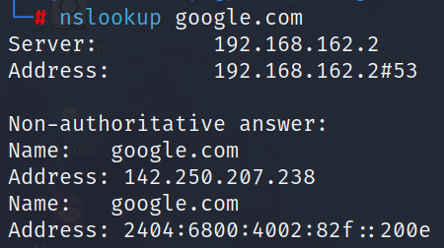

* **dig (Domain Information Groper)**

The dig tool gives elaborative information on the various kinds of DNS records a host has, such as the available DNS data for a host, mail server or MX records, and name server or NS records.

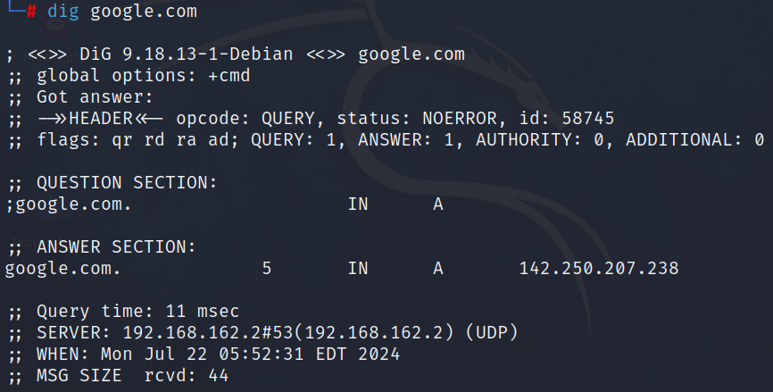

#### **2. Zone Transfer**

A zone transfer can potentially reveal all DNS records within a domain if the server is misconfigured to allow it. This technique involves querying a DNS server to fetch the entire zone file.

* **Performing a zone transfer**:

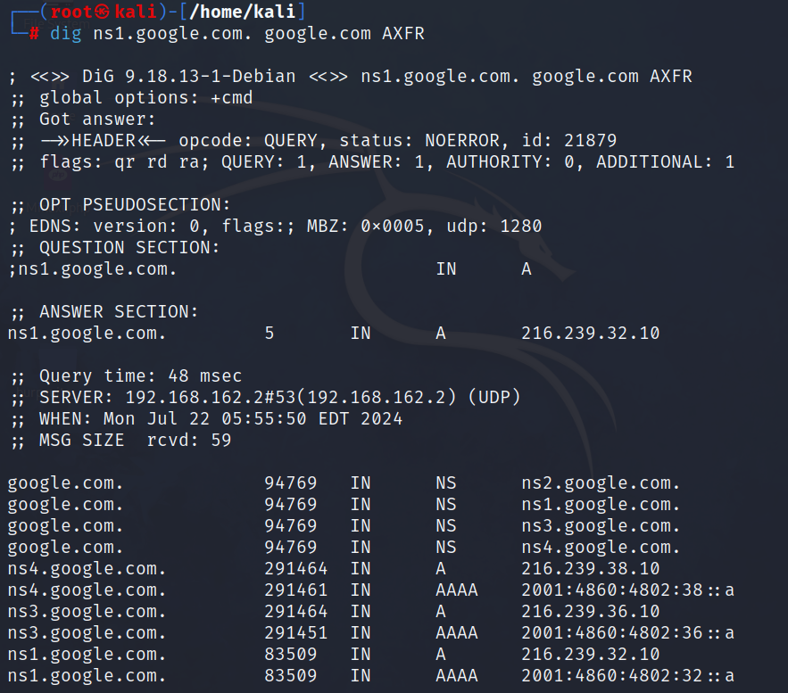

#### **3. Utilize Specialized DNS Enumeration Tools**

#### Leverage tools like **dnsenum** and **dnsrecon**, for a comprehensive DNS enumeration.

#### **Using dnsenum:** Dnsenum is a flexible tool that finds different DNS records for a domain such as A, AAAA, MX, NS, SOA, and others.

#### It can discover subdomains by trying many combinations or by asking public sources like Google. Also, Dnsenum does reverse DNS searches to find domain names linked to specific IP addresses.

#### It also checks for DNS zone transfers, which can show detailed info about how a domain is set up. The tool supports IPv6 address enumeration and can use various public DNS resolvers for its queries, which makes its work more reliable and less likely to fail.

#### 

#### 

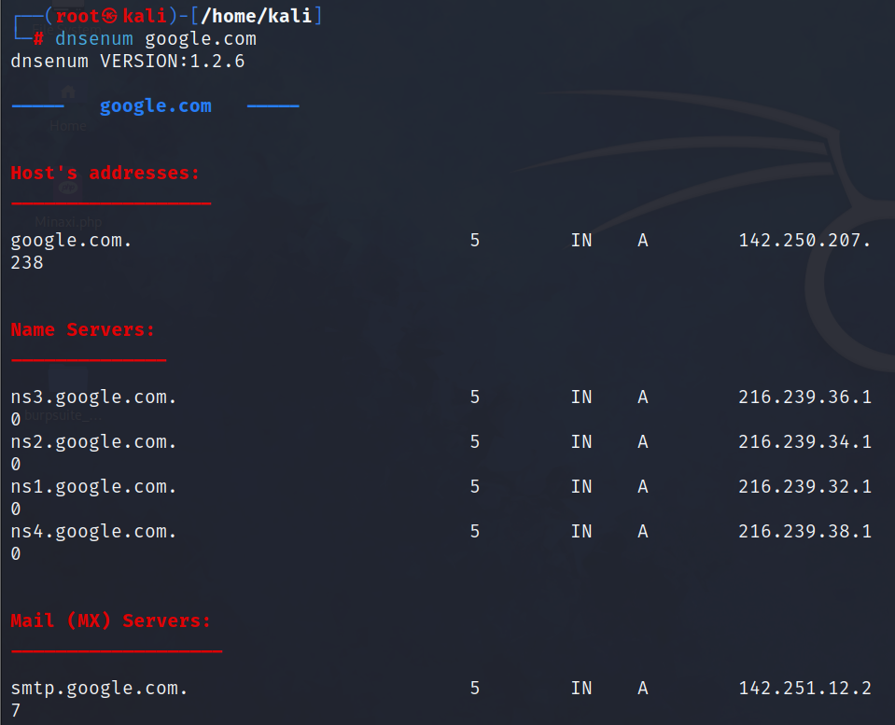

* **Using dnsrecon**: Dnsrecon serves as a strong DNS mapping tool that cybersecurity experts use to collect in-depth DNS details about a target domain.

It gathers different DNS records (A, AAAA, MX, NS, and others), looks for zone transfers, and can carry out brute-force subdomain mapping.

This tool also helps to do reverse DNS searches, spots wildcard DNS records and tries zone walking on domains that have DNSSEC enabled.

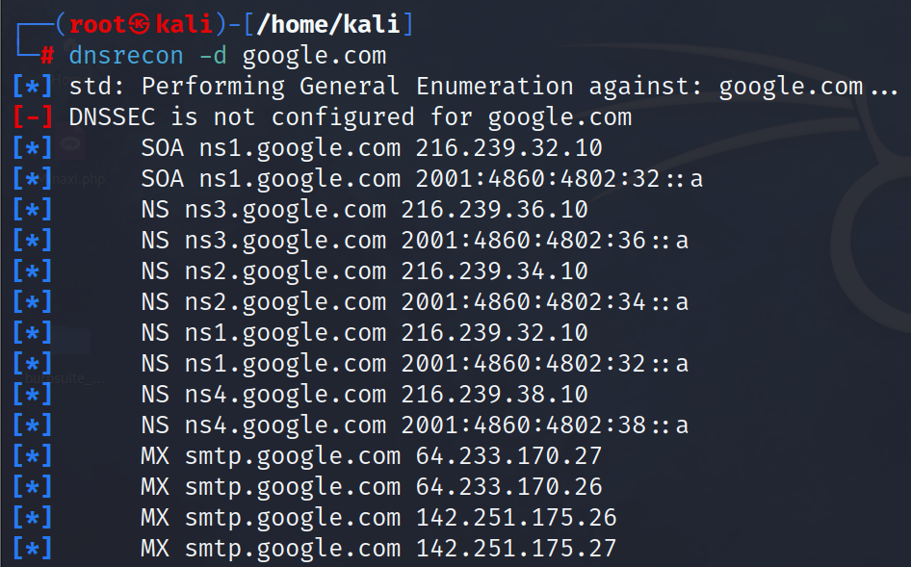

### **Conclusion**

DNS enumeration is a fundamental aspect of network reconnaissance and security assessments. By using a combination of command-line tools, online services, and specialized enumeration software, you can gather extensive information about a target domain’s DNS infrastructure.